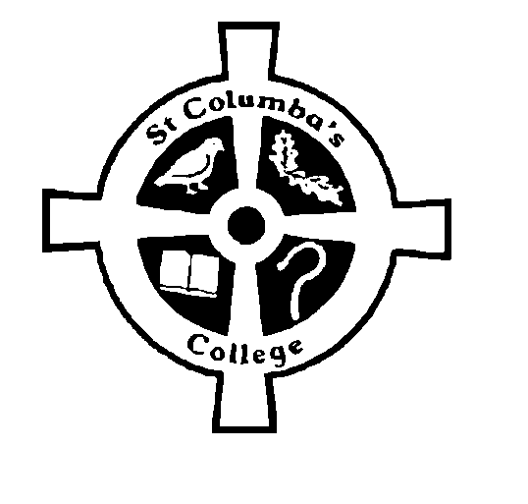ST COLUMBA’S COLLEGE
2 Ballyphilip Road
Portaferry
Newtownards
Co Down
BT22 1RB
Telephone: 028 42728323
Fax No: 028 42729536
Headmaster: Michael G Breen B Ed, M Sc, DASE

Inspiring Learning, Celebrating Success, Respecting Others

Dear Parents/Guardians

I want to take this opportunity to share with you the remarkable achievements of our recent Year 12 students. They have had outstanding success and we must congratulate them on their performance.

I am going to share some statistics with you that will help to put their success into perspective, so please bear with me.

- 100% of our students attained 5 GCSEs A*-C
- 73% achieved 5 GCSEs A*-C including English and Maths
- 84% gained 7GCSEs A*-C
- 69% achieved 7 or more GCSEs or equivalent at grades A*-C including English and Maths
- 73% achieved 5 or more GCSEs or equivalent at grades A*-C including GCSE English and GCSE Mathematics and one or more Science subjects
- 38% achieved 5 or more GCSEs or equivalent at grades A*-C including GCSE English and GCSE Mathematics and one or more Modern Languages (we must bear in mind that Modern Language is an optional subject)

These results are all the more remarkable when we compare them with the performance of all non-selective schools across Northern Ireland.

Year 12 | Non-grammar | St Columba’s College
% of Year 12 pupils achieving 5 or more GCSEs or equivalent at Grades A*-C | 72.7 | 100
% of Year 12 pupils achieving 5 or more GCSEs or equivalent at Grades A*-G | 97.6 | 100
% of Year 12 pupils achieving no GCSEs or equivalent | 0.1 | 0.0
% of Year 12 pupils achieving 7 or more GCSEs or equivalent at Grades A*-C including GCSE English and GCSE Mathematics | 41.9 | 69.23
% of Year 12 pupils achieving 5 or more GCSEs or equivalent at Grades A*-C including GCSE English and GCSE Mathematics | 47.0 | 73.08

The gap as you can see is very significant.

Please allow me to go one step further and to share with you that across Northern Ireland there are 37 similar schools within our Free School Meal Band. The table below shows St Columba’s College in the top 5% of these schools. There are only 2 schools in this category and I hope I am not being arrogant when I say that St Columba’s College could be in the number 1 spot.

 | Lower quartile | Median | Upper quartile | 95th Percentile | St Columba’s College
% of Year 12 pupils achieving 5 or more GCSEs or equivalent at Grades A*-C including GCSE English and GCSE Mathematics | 36.8 | 43.5 | 49.2 | 65.2 | 73
% of Year 12 pupils achieving 5 or more GCSEs or equivalent at Grades A*-C | 59.6 | 72.3 | 83.2 | 93.3 | 100
% of Year 12 pupils achieving 5 or more GCSEs or equivalent at Grades A*-G | 94.2 | 98.1 | 100 | 100 | 100
% of Year 12 pupils achieving 1 or more GCSEs or equivalent | 100 | 100 | 100 | 100 | 100

Whilst these results of themselves are outstanding, they are not unusual for St Columba’s College. The school has consistently performed above the Northern Ireland Average for similar schools. We meet the Entitlement Framework. We offer a broad and balanced curriculum. Our curriculum is inclusive and open to all pupils. All pupils do GCSE English, Maths, Science and RE and all have access to all subjects guided by pupil preference, chosen career pathway, parental input, Career Officer guidance and performance at Key Stage 3. We are very much an equal opportunity school.

We are proud of the efforts of our students and we congratulate them on their achievements. I would also like to thank you, their parents/guardians, for your help, support and encouragement over the years. It has been a major team effort with remarkable results – a time to celebrate and to spread the good news.

Yours faithfully

Michael Breen
Headmaster







